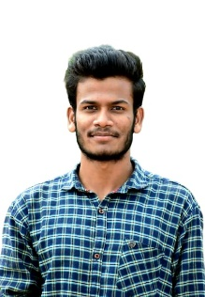

**Ranjithkumar S**

Mail: [ranjithkumar60304@gmail.com](mailto:ranjithkumar60304@gmail.com)

Phone no: 9095262594

Graduate in Information Technology looking for place to implement the new ideas and technology in the field of Information Technology.

**Skill Set**

Advanced : C

Moderate : Java, HTML, CSS ,PHP

Basic : JavaScript, Python

**Area of Interest**

* Data Structure
* Java
* DBMS

**Project Done**

1. **Freelancer Management(web based)**

**Objective:** A bridge between jobber and employee(freelance workers)

**Front End :** HTML, CSS

**Back End :** PHP, MySQL

**Tools used:** Notepad++, XAMPP

**Duration:** 1 month

1. **Acadamic Data Management(web based)**

**Objective:** Collect academic data from student for easy management of student activities.

**Front End :** HTML, CSS

**Back End :** JavaScript, PHP, MySQL

**Tools used:** Visual studio code, Notepad++, XAMPP

**Duration:** 1 month

**Achievement and Participations**

* NPTEL Online Certification on “Object Oriented Analysis and Design”.
* “HTML, CSS & JavaScript - Certificate Course for Beginners”- Online Course at Udemy on May,2021
* “Python Fundamentals for Beginners”- Online Course at Great Learning on September,2021.
* Active member in Citizen Consumer Club.

**Academics**

Under Graduate in B.TECH - IT (2019-2023) 8.94cgpa

Dr. Mahalingam College of Engineering & Technology (upto 4th sem)

HSC-State Board of Tamil Nadu (2018-2019) 83%

RG Matric Hr. Sec. School

SSLC- State Board of Tamil Nadu (2016-2017) 94%

RG Matric Hr. Sec. School

**Strengths**

* Self learning .
* Time management

**Hobbies**

* Listening to songs.
* Gardening.
* Time with pets.

**Personal Information**

Address : 3/181-Moongiltholuvu, Udumalpet, Tirupur, Tamil Nadu.

Date of Birth : 08-04-2001

Nationality : Indian

**Declaration**

I hereby declare that all the above furnished information is true to my knowledge

**Place:**

**Data: (RANJITHKUMAR S)**